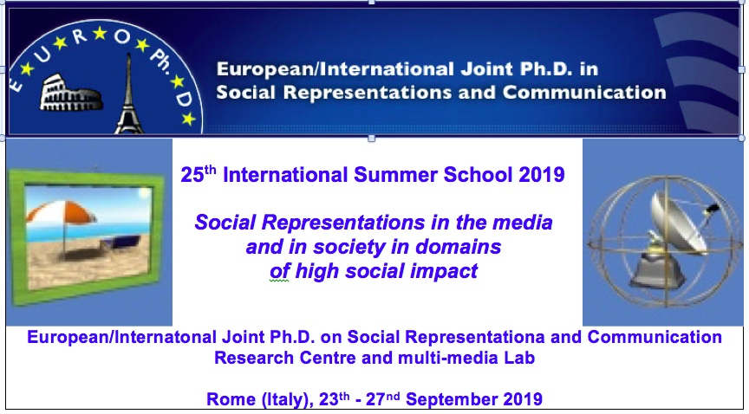

EVENT EVALUATION FORM

to be sent to the e-mail account of the Program Director and Co-ordinator : annamaria.derosa@uniroma1.it

1. Participant details

Name and Surname: Country of origin: Denomination and Country of your institutional affiliation:

Year of enrolment in the Euro/Int. Joint PhD in Social Representations and Communication:

E-mail address:

2. Your personal experience

Judgement of academic/learning outcomes of the International Summer School/Lab Meeting:
scale 1-5 : 1=poor/negative, 5=excellent
1 – 2 – 3 – 4 – 5

Judgement of personal outcomes of the International Summer School/Lab Meeting:
scale 1-5 : 1=poor/negative, 5=excellent
1 – 2 – 3 – 4 – 5

How would you rate the organisation and management of the event?
scale 1-5 : 1=poor/negative, 5=excellent
1 – 2 – 3 – 4 – 5

How would you rate the venue (for those who have attended face to face the event)?
scale 1-5 : 1=poor/negative, 5=excellent
1 – 2 – 3 – 4 – 5

How would you rate the on-line connection (for those who have attended on-line the event)?
scale 1-5 : 1=poor/negative, 5=excellent
1 – 2 – 3 – 4 – 5

How satisfied were you with the academic activities and the pedagogical aspects of the International Summer School /Lab Meeting in terms of the following aspects?
scale 1-5: 1=not at all, 5=very much
The number of hours taught 1 – 2 – 3 – 4 – 5
The equipment used 1 – 2 – 3 – 4 – 5
The overall quality of teaching 1 – 2 – 3 – 4 – 5
The expected learning outcomes 1 – 2 – 3 – 4 – 5

Did you encounter any serious problems during the International Summer School /Lab Meeting?
scale 1-5: 1=not at all, 5=very much
1 – 2 – 3 – 4 – 5
If yes, please specify :

Overall evaluation of the International Summer School /Lab Meeting:
scale 1-5 : 1=poor/negative, 5=excellent
1 – 2 – 3 – 4 – 5

The best lessons learned from participating in the training event:

Recommendations and ideas for the International Summer School /Lab Meeting organisers:

